**FINANCE MANAGEMENT SYSTEM**

**FMS DOCUMENTATION: TEAM 8**

At **Finance Manager**, our mission is to simplify financial management by providing users with tools to track, plan, and optimize their finances. This dashboard allows users to monitor their financial activities, from tracking transactions to generating insightful reports.

**1. Home Page**

**Purpose:**  
The central dashboard where users navigate the platform.

**Elements:**

* **Navigation Menu:**
  + Dashboard: Overview of user financial activity

.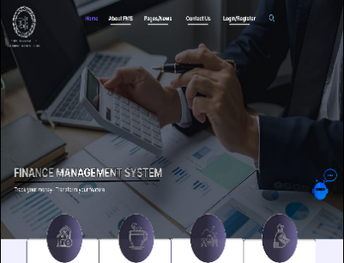

* + Transactions: View and manage financial transactions.
  + Budgeting: Set personal budgets.

Reports: Generate financial reports

* + Settings: Adjust account settings.
* **Account Overview:**  
  Displays total balance, savings, and current expenses.
* **Recent Transactions:**  
  List of the latest financial activities.
* **Graph Section:**  
  Visual representation of income, expenses, and savings.
* **Notifications:**  
  Alerts and reminders regarding financial events or deadlines.

**2. Register Page**

**Purpose:**  
To allow new users to create an account on the platform.

**Elements:**

* **Input Fields:**
  + Name
  + 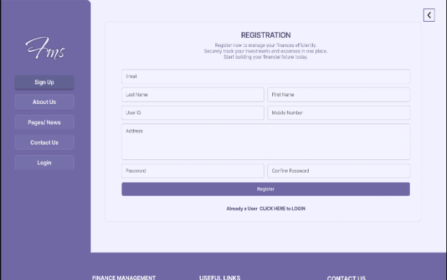Email

**3. Login Page**

**Purpose:**  
For existing users to log in and access the platform.

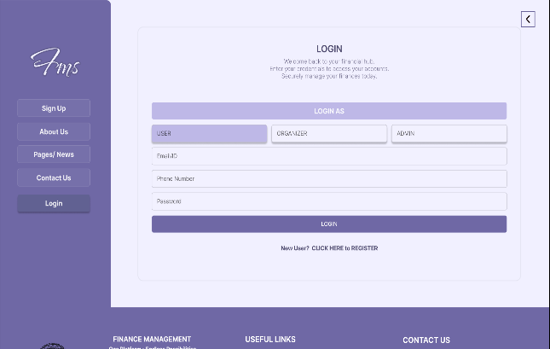

**Elements:**

* **Input Fields:**
  + Email
  + Password
* **Checkbox:**
  + Remember Me: Saves login credentials for future sessions.
* **Links:**
  + Forgot Password?: Redirects to password recovery.
  + Sign Up: Option for new users to create an account.
* **Button:**
  + Login: Logs the user into the system.

**4. User Page**

**Purpose:**  
To display user details and allow management of their personal account information.

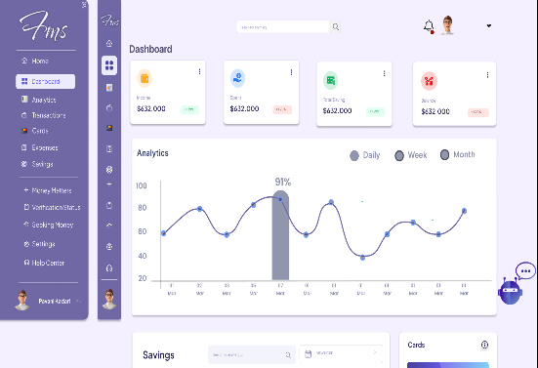

**Elements:**

* **Profile Section:**
  + Displays user information (e.g., name, email, account status).
* **Financial Summary:**
  + Shows the user's current financial data (balance, recent transactions, investments).
* **Edit Profile Button:**
  + Allows users to update their information or preferences.
* **Navigation Menu:**
  + Overview
  + Financial Data
  + Notifications

**5. User Components**

**Purpose:**  
To manage different sections related to user financial activities and settings.

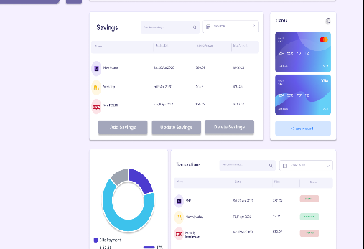

**Elements:**

* **Profile Info:**  
  Display user's personal information, including their email, phone number, and preferences.
* **Transactions History:**  
  Displays a table of all financial transactions with sorting and filtering options.
* **Settings Section:**  
  Allows users to adjust preferences like notification settings, and update their profile.
* **Budget Overview:**  
  Displays set budgets, progress bars for each budget, and an option to update or add a budget.

**6. Organisation Page**

**Purpose:**  
To provide an overview of organization-related financial data and activities.

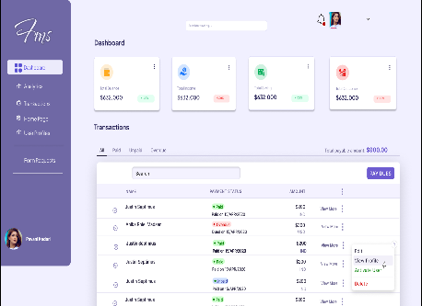

**Elements:**

* **Financial Overview:**  
  Summary of the organization’s financial data including revenue, expenses, and balance.
* **Team Management:**  
  Displays list of team members and their roles in financial operations.
* **Navigation Menu:**
  + Overview
  + Budgeting
  + Transactions
  + Reports
  + Team
* **Reports Section:**  
  Allows organization administrators to generate financial reports for the organization.

**7. Organisation Components**

**Purpose:**  
To manage various aspects of organization financial activities.

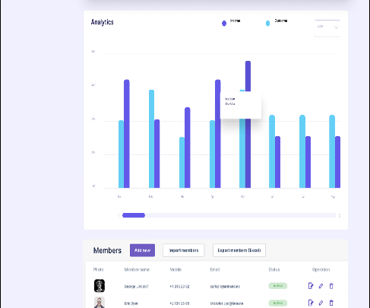

**Elements:**

* **Team List:**  
  Displays all team members along with their roles.
* **Financial Transactions:**  
  Displays and filters organization-wide transactions with details for each.
* **Reports Generation:**  
  Section for generating quarterly, annual, and custom financial reports.
* **Budget Allocation:**  
  Manage organization budgets for various departments or activities.

**8. Admin Page**

**Purpose:**  
The main dashboard for administrators to monitor platform usage and manage data.

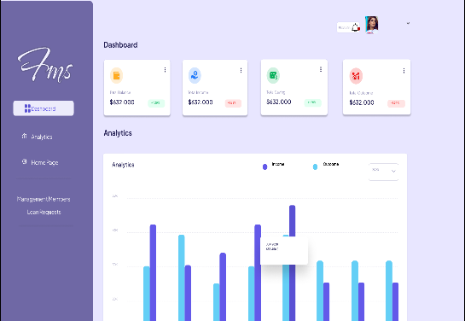

**Elements:**

* **Navigation Menu:**
  + Home: Admin dashboard overview.
  + Users: Manage user accounts.
  + Data: Oversee user-submitted financial data.
  + Reports: Generate administrative reports.
  + Settings: Adjust platform settings and manage alerts.
* **User Overview:**  
  Displays active users, recent sign-ups, and user statistics.
* **Financial Overview:**  
  Summary of platform-wide financial transactions and key metrics.
* **Graph Section:**  
  Visual representation of overall platform performance.

**9. Admin Components**

**Purpose:**  
To manage and oversee different sections of the platform as an administrator.

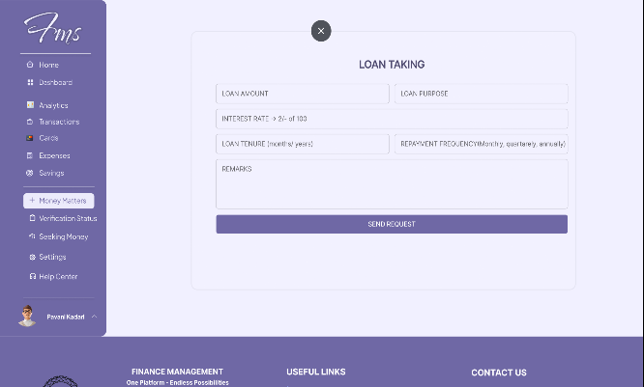

**Elements:**

* **User Management:**  
  View, edit, or delete user accounts. Includes filtering and search options for easy navigation.
* **Data Management:**  
  Approve, reject, or edit user-submitted data related to finances.
* **Platform Settings:**  
  Manage platform-level settings such as notifications, API integrations, and financial alerts.
* **Report Generation:**  
  Tools to generate reports on platform activity, including user engagement and financial performance.

USER PROFILE:

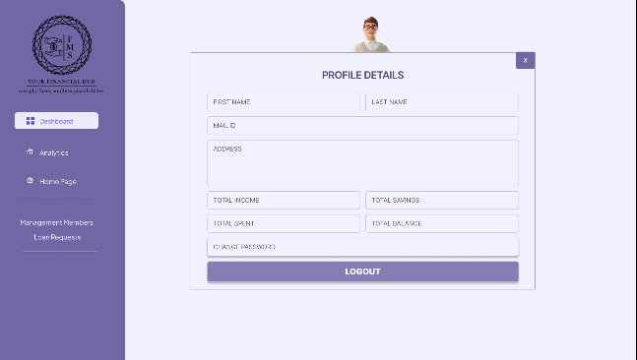

FOOTER PAGE:

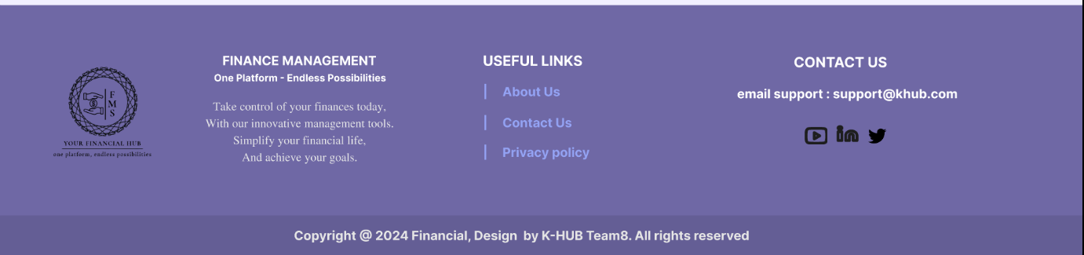

**TABLET VIEW:**

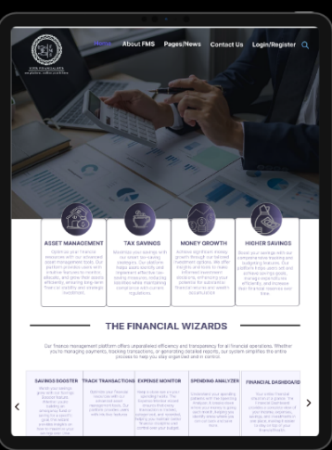 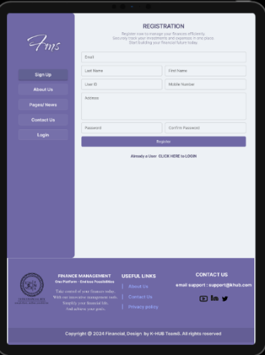 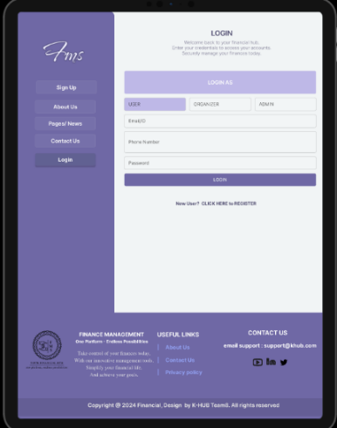

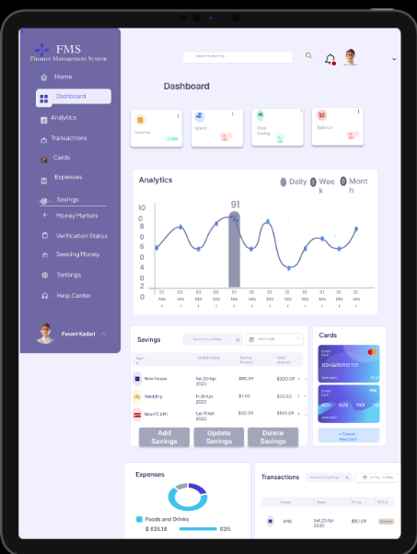 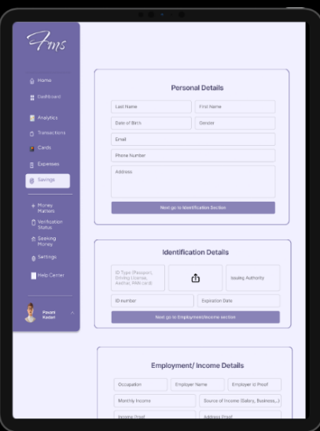 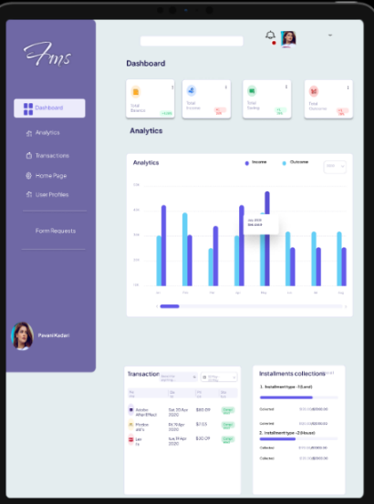

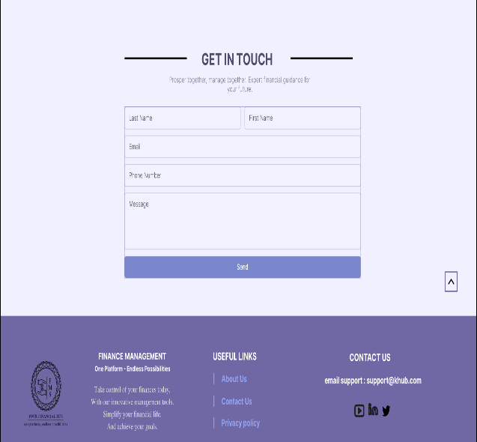 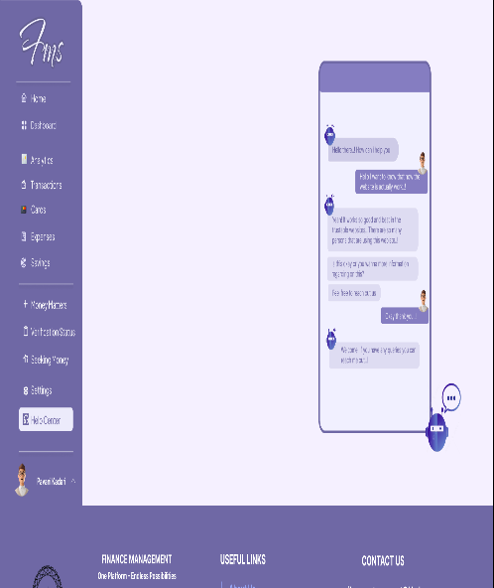

**PHONE VIEW:**

